CHANGES HISTORY
PIC | Date | Remarks
BJM.MR | 2018.05.04 | Created
Ghaida | 2018.05.04

TOC
- System administrator:
- Parameter Client RiskLevel
- Parameter Client Status
- Parameter Client Type

- SIMPI SUPPORT
- Parameter Client Occupation
- Parameter Client Region
- Parameter Client Document Type
- Parameter Client ID Card Type
- Parameter Client Business type
- Parameter Client MaritalStatus
- Parameter Client Business Activity
- Parameter Client Kyc
- Parameter Client Kyc answer
- Parameter Client Education Level
- Parameter Client Education Type

Diagram ENTITY RELATIONSHIP

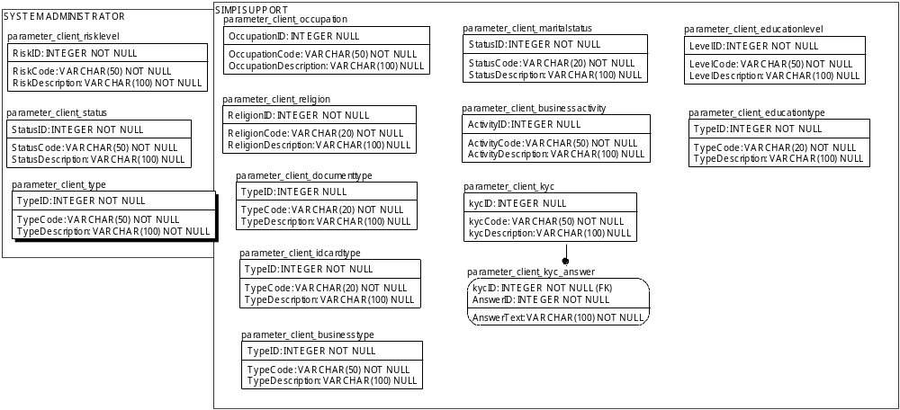

TABLE RELATIONSHIP
No | Table 1 | Table 2 | Type (1:1; 1:N; M:N) | Description
 | parameter_client_kyc | parameter_client_kyc_answer | M:N

- System Administrator

Name |  | parameter_client_risklevel
Objective
No | Column |  | Type | Rule  (PK, FK, Key, NN, Unik, Index) | Description
1. | RiskID |  | Integer | NN
2. | RiskCode |  | Varchar(50) | NN
3. | RiskDescription |  | Varchar(100) | NN

SAMPLE DATA
No | Column | Sample 1 | Sample 2 | Sample 3 | Sample 4
1. | UserID | 1 | 2 | 3
2. | UserLogin | Low | Low to Moderate | Moderate
3. | UserPassword | Low | Low to Moderate | Moderate

Name |  | parameter_client_status
Objective
No | Column |  | Type | Rule  (PK, FK, Key, NN, Unik, Index) | Description
1. | StatusID |  | Integer | NN
2. | StatusCode |  | Varchar(50) | NN
3. | StatusDescription |  | Varchar(100) | Null

SAMPLE DATA
No | Column | Sample 1 | Sample 2 | Sample 3 | Sample 4
1. | StatusID | 1 | 2 | 3
2. | StatusCode | ACTIVE | PENDING | DELETE
3. | StatusDescription | Active | Pending | Delete

Name |  | parameter_client_type
Objective
No | Column |  | Type | Rule  (PK, FK, Key, NN, Unik, Index) | Description
1. | TypeID |  | Integer | NN
2. | TypeCode |  | Varchar(50) | NN
3. | TypeDescription |  | Varchar(100) | Null

SAMPLE DATA
No | Column | Sample 1 | Sample 2 | Sample 3 | Sample 4
1. | TypeID | 1 | 2 | 3 | 4
2. | TypeCode | INDIVIDUAL | INSTITUTIONAL | SUB ACCOUNT INDIVIDUAL | SUB ACCOUNT INSTITUTIONAL
3. | TypeDescription | client individual | client institutional | client individual under another client | client institutional under another client

- SImpi support

Name |  | Parameter_client_occupation
Objective
No | Column |  | Type | Rule  (PK, FK, Key, NN, Unik, Index) | Description
1. | OccupationID |  | Integer | NN
2. | OccupationCode |  | Varchar(50) | NN
3. | OccupationDescription |  | Varchar(100) | Null

SAMPLE DATA
No | Column | Sample 1 | Sample 2 | Sample 3 | Sample 4
1. | OccupationID | 1 | 2 | 3 | 4
2. | OccupationCode | Student/Graduate Student/Post Graduate | Housewife | Enterpreneur | Civil Servant
3. | OccupationDescription | Student/Graduate Student/Post Graduate | Housewife | Enterpreneur | Civil Servant

Name |  | parameter_client_religion
Objective
No | Column |  | Type | Rule  (PK, FK, Key, NN, Unik, Index) | Description
1. | ReligionID |  | Integer | NN
2. | ReligionCode |  | Varchar(50) | NN
3. | ReligionDescription |  | Varchar(100) | Null

SAMPLE DATA
No | Column | Sample 1 | Sample 2 | Sample 3 | Sample 4
1. | ReligionID | 1 | 2 | 3 | 4
2. | ReligionCode | Islam | Protestant | Catholic | Hinduism
3. | ReligionDescription | Islam | Protestant | Catholic | Hinduism

Name |  | parameter_client_documenttype
Objective
No | Column |  | Type | Rule  (PK, FK, Key, NN, Unik, Index) | Description
1. | TypeID |  | Integer | NN
2. | TypeCode |  | Varchar(50) | NN
3. | TypeDescription |  | Varchar(100) | NN

SAMPLE DATA
No | Column | Sample 1 | Sample 2 | Sample 3 | Sample 4
1. | TypeID | 1 | 2 | 3 | 4
2. | TypeCode | Dokumen Pendirian | SIUP | TDP | NPWP
3. | TypeDescription | Deed of Establishment | Surat Ijin Usaha | Tanda Daftar Perusahaan | Nomor Pokok Wajib Pajak

Name |  | parameter_client_idcardtype
Objective
No | Column |  | Type | Rule  (PK, FK, Key, NN, Unik, Index) | Description
1. | TypeID |  | Integer | NN
2. | TypeCode |  | Varchar(50) | NN
3. | TypeDescription |  | Varchar(100) | NN

SAMPLE DATA
No | Column | Sample 1 | Sample 2 | Sample 3 | Sample 4
1. | TypeID | 1 | 2
2. | TypeCode | KTP | PASPORT
3. | TypeDescription | KTP | PASPORT

Name |  | parameter_client_idcardtype
Objective
No | Column |  | Type | Rule  (PK, FK, Key, NN, Unik, Index) | Description
1. | TypeID |  | Integer | NN
2. | TypeCode |  | Varchar(50) | NN
3. | TypeDescription |  | Varchar(100) | NN

SAMPLE DATA
No | Column | Sample 1 | Sample 2 | Sample 3 | Sample 4
1. | TypeID | 1 | 2 | 3 | 4
2. | TypeCode | State Owned Company/Public | Private | Social | Joint Venture
3. | TypeDescription | Badan Usaha Milik Negara | Perusahaan Penanaman Modal Dalam Negeri | Aktivitas Sosial | Perusahaan Patungan

Name |  | parameter_client_maritalstatus
Objective
No | Column |  | Type | Rule  (PK, FK, Key, NN, Unik, Index) | Description
1. | StatusID |  | Integer | NN
2. | StatusCode |  | Varchar(50) | NN
3. | StatusDescription |  | Varchar(100) | NN

SAMPLE DATA
No | Column | Sample 1 | Sample 2 | Sample 3 | Sample 4
1. | StatusID | 1 | 2 | 3
2. | StatusCode | Single | Married | Divorce
3. | StatusDescription | Single | Married | Divorce

Name |  | parameter_client_businessactivity
Objective
No | Column |  | Type | Rule  (PK, FK, Key, NN, Unik, Index) | Description
1. | ActivityID |  | Integer | NN
2. | ActivityCode |  | Varchar(50) | NN
3. | ActivityDescription |  | Varchar(100) | NN

SAMPLE DATA
No | Column | Sample 1 | Sample 2 | Sample 3 | Sample 4
1. | ActivityID | 1 | 2 | 3 | 4
2. | ActivityCode | Corporate | Foundation | Financial Institution | Insurance
3. | ActivityDescription | Perusahaan | Yayasan | Lembaga Keuangan | Asuransi

Name |  | parameter_client_kyc
Objective
No | Column |  | Type | Rule  (PK, FK, Key, NN, Unik, Index) | Description
1. | kycID |  | Integer | Null
2. | kycCode |  | Varchar(50) | NN
3. | kycDescription |  | Varchar(100) | Null

SAMPLE DATA
No | Column | Sample 1 | Sample 2 | Sample 3 | Sample 4
1. | kycID | 1 | 2 | 3 | 4
2. | kycCode | Tujuan Investasi (Individual) | Sumber Dana (Institusi) | Penghasilan Setahun (Individual) | Bentuk Badan Usaha
3. | kycDescription | Investment Objective | Source of Fund | Income Level (IDR) | Bentuk Badan usaha

Name |  | parameter_client_kyc_answer
Objective
No | Column |  | Type | Rule  (PK, FK, Key, NN, Unik, Index) | Description
1. | kycID |  | Integer | FK
2. | AnswerID |  | Integer | NN
3. | AnswerText |  | Varchar(100) | Null

SAMPLE DATA
No | Column | Sample 1 | Sample 2 | Sample 3 | Sample 4
1. | kycID
2. | AnswerID
3. | AnswerText

Name |  | parameter_client_educationlevel
Objective
No | Column |  | Type | Rule  (PK, FK, Key, NN, Unik, Index) | Description
1. | LevelID |  | Integer | NN
2. | LevelCode |  | Varchar(50) | NN
3. | LevelDescription |  | Varchar(100) | NN

SAMPLE DATA
No | Column | Sample 1 | Sample 2 | Sample 3 | Sample 4
1. | LevelID | 1 | 2 | 3 | 4
2. | LevelCode | Primary School | Junior High School | Senior High School | Diploma
3. | LevelDescription | Primary School | Junior High School | Senior High School | Diploma

Name |  | parameter_client_educationtype
Objective
No | Column |  | Type | Rule  (PK, FK, Key, NN, Unik, Index) | Description
1. | TypeID |  | Integer | NN
2. | TypeCode |  | Varchar(50) | NN
3. | TypeDescription |  | Varchar(100) | NN

SAMPLE DATA
No | Column | Sample 1 | Sample 2 | Sample 3 | Sample 4
1. | TypeID | 1 | 2 | 3 | 4
2. | TypeCode | Formal | Course | Workshop | Training
3. | TypeDescription | Formal | Course | Workshop | Training

